Group 6

Part 1: Scenario Assignment
- Online Marketplace Platform

Part 2: System Planning
- Project Overview
- FrinStore: An Local Ice Cream Online Marketplace Platform
- Problem Statements:
  - Customers cannot conveniently browse ice cream products, flavors, and availability without visiting the physical store.
  - Manual ordering through chat or phone causes order errors, delays, and poor tracking of customer purchases.
  - The store has no centralized system for managing inventory, orders, and sales reporting.
- Local FrinStore (ice cream shop) customers, store staff, and store administrators.
- Scope:
  - Included:
    - Online product catalog browsing
    - Customer registration and login
    - Add to cart and checkout system
    - Online payment integration
    - Order tracking and notifications
    - Admin dashboard for inventory and sales
  - Excluded:
    - Third-party delivery logistics system integration
    - AI recommendation engine
    - Franchise or multi-branch management
    - Offline POS integration

- Requirements Identification
- Functional Requirements
  - User Registration and Login Authentication
  - Product browsing and search by flavor, price, or category
  - Add to card and checkout functionality
  - Online payment integration (GCash, card, etc.)
  - Order tracking and order history
  - Admin inventory and product management
  - Sales report generation
  - Customer notifications (order confirmation, status updates)
- Non-functional Requirements
  - System must load within 3 seconds under normal traffic
  - Must support at least 500 concurrent users
  - Customer and payment data must be encrypted
  - System uptime availability of 99%
  - Mobile responsive interface
  - Secure authentication and role-based access control
  - Backup database every 24 hours

Part 3: SDLC Phase Plan
- Planning
  - Activities:
    - Identify Stakeholders
    - Define project goals and scope
    - Feasibility study(technical, operational, economic)
    - Budget estimation
    - Project schedule creation

  - Project Charter:
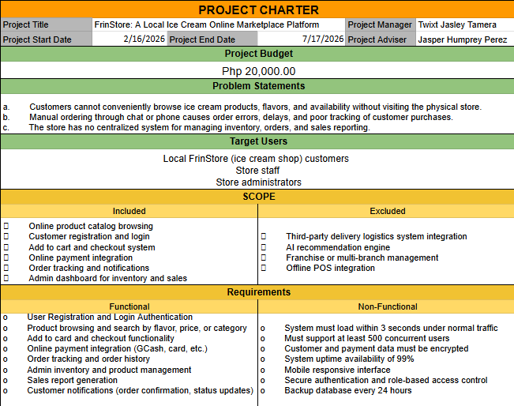
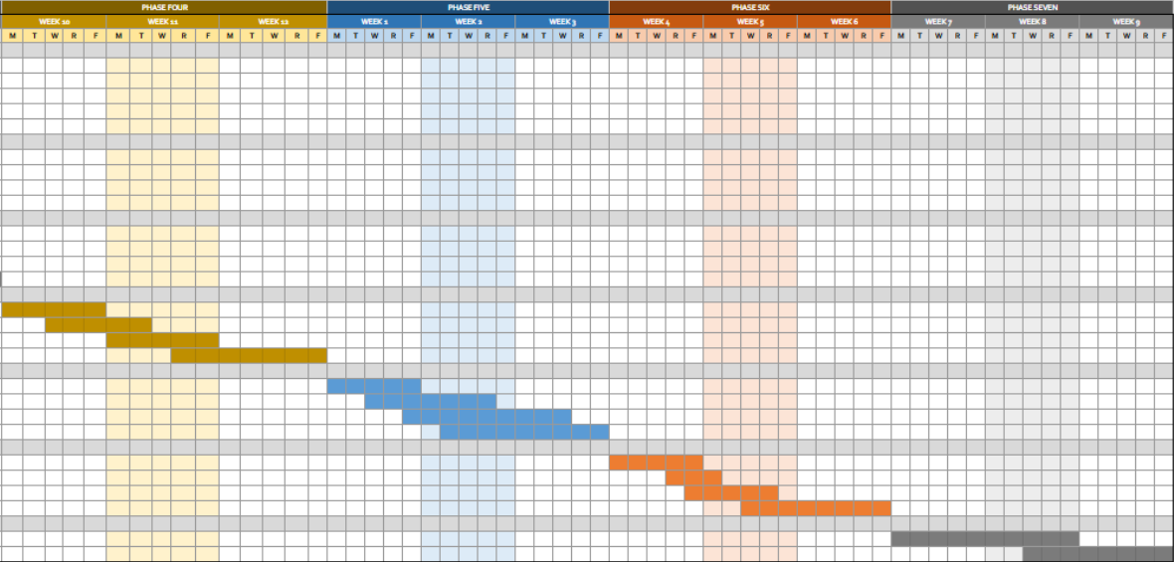
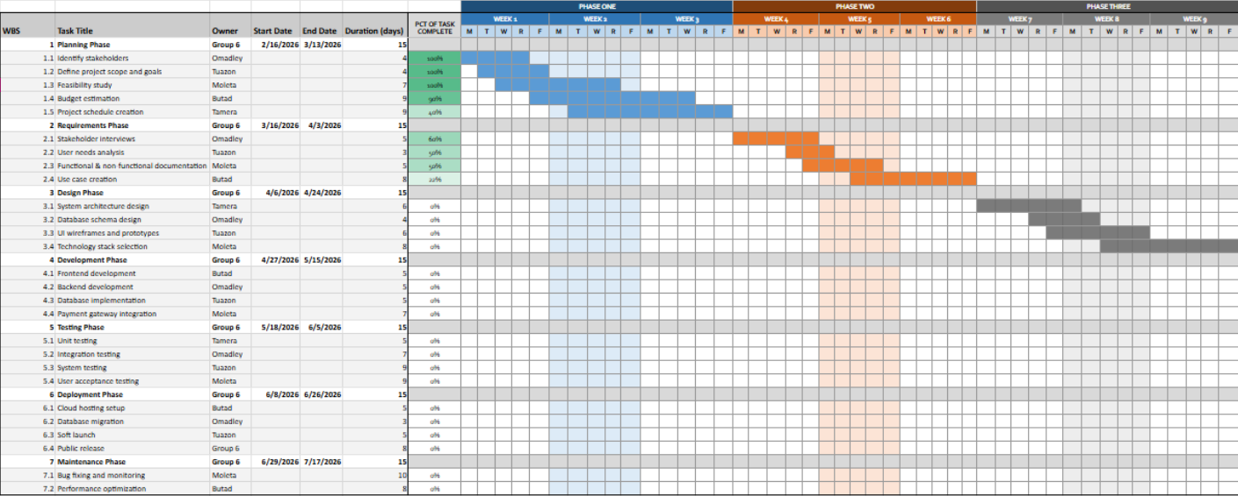
  - Gantt Chart

  - Expected Deliverables:
    - Approved project proposal
    - Project charter
    - Initial timeline and budget
- Requirements:
  - Activities:
    - Stakeholder interviews
    - User needs analysis
    - Functional and non-functional requirement documentation
    - Use case creation
  - Expected Deliverables:
    - Software Requirements Specification (SRS)
    - Use case diagrams
    - Requirements approval document
- Design:
  - Activities:
    - System architecture design
    - Database schema design
    - UI wireframes and prototypes
    - Technology stack selection
  - Expected Deliverables:
    - System design document
    - ER diagram
    - UI mockups
    - Architecture diagram
- Development:
  - Activities:
    - Frontend and backend coding
    - Database implementation
    - API development
    - Integration of payment gateway
  - Expected Deliverables:
    - Working software modules
    - Source code repository
    - Developer documentation
- Testing:
  - Testing Types to Use:
    - Unit testing
    - Integration testing
    - System testing
    - User acceptance testing (UAT)
    - Performance testing
  - Expected Deliverables:
    - Test plans and test cases
    - Bug reports
    - Test summary report
    - Approved tested system
- Deployment:
  - Deployment Strategy:
    - Cloud hosting setup
    - Database migration
    - System configuration
    - Soft launch with limited users
    - Full public release
- Maintenance:
  - Future Improvements:
    - Delivery tracking integration
    - Loyalty rewards system
    - AI product recommendations
    - Mobile application version
    - Multi-branch support

SDLC Model Selection
- SDLC Model:
  - Agile
- Justification:
  - Why is this the best Model?
    - Allows continuous improvement based on customer feedback.
    - Faster release of working features.
    - Flexible to changing business requirements
    - Frequent testing reduces major system failures
  - Why are the other models less suitable?
    - Waterfall is too rigid and difficult to modify once development begins
    - Spiral model is complex and costly for a small business system
    - V-model requires strict documentation and is less flexible
  - What risks does this model reduce?
    - Requirement misunderstanding
    - Late discovery of system errors
    - Low user satisfaction
    - Project delays due to large-scale changes

Visual Diagram
- SDLC Phase Flow Diagram
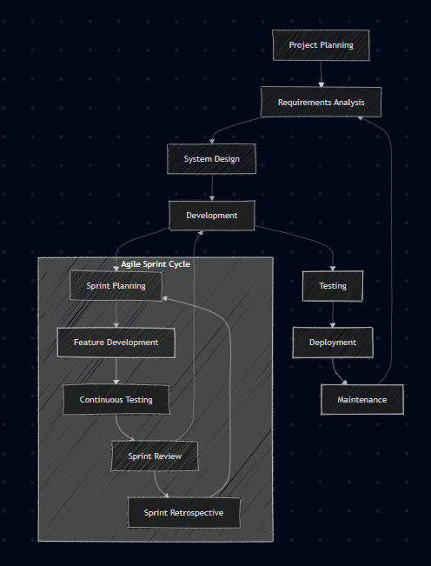

- Model Representation (Sprint Cycle)
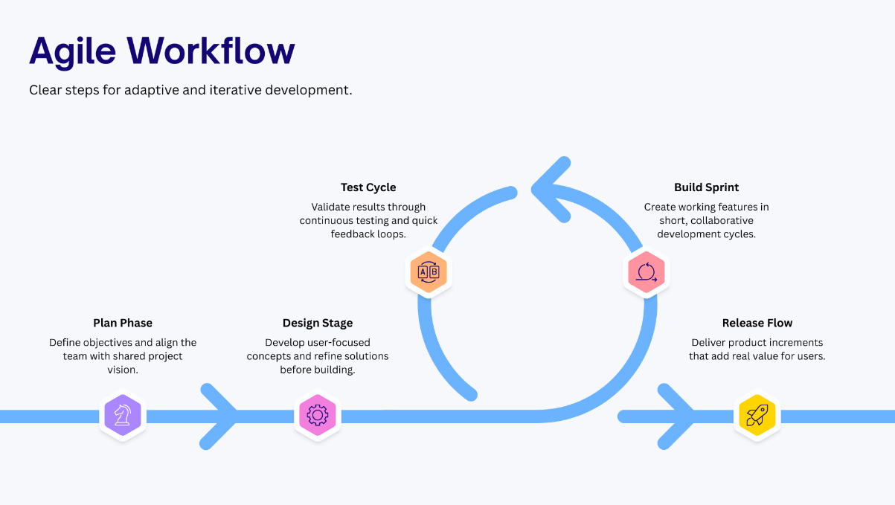

Members:
- Omadley (Leader)
- Moleta
- Butad
- Tamera
- Ancog

